THIS & THAT
This and that gebruik je voor enkelvoud. En je gebruikt het om terug te verwijzen naar een zelfstandig naamwoord. In het Nederlands gebruiken we dan vaak die of dat.

- I really like this book; it's so interesting! - Ik vind dit boek echt leuk, het is zo interessant!
- Can you pass me that pen, please? - Kun jij mij die pen aangeven, a.u.b.?

this that
dichtbij veraf

Oefening 1 Enkelvoud this & that
- Look at _______________ beautiful sunset; it's breathtaking!
- Do you see _______________ bird over there? It's so colourful.
- I can't believe _______________ movie is so good!
- Can you please pass me _______________ newspaper on the table?
- Do you remember _______________ restaurant where we had dinner last night?
- I bought _______________ shirt because the colour caught my eye.
- I saw _______________ interesting documentary about wildlife conservation.
- Could you grab _______________ bag for me from the top shelf?
- I'm thinking of redecorating; what do you think about _______________ colour for the walls?
- Look at _______________ incredible artwork on the museum wall.
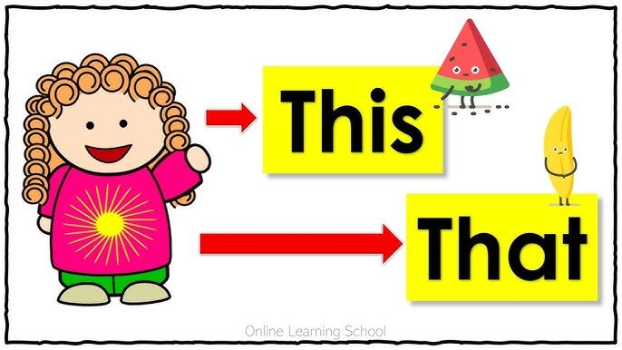

THESE & THOSE

These and those gebruik je voor meervoud. En je gebruikt het om terug te verwijzen naar een zelfstandig naamwoord. In het Nederlands gebruiken we dan vaak die of deze.

- I bought some new shoes, and I love how comfortable these are.
- Ik kocht een paar nieuwe schoen en ik hou ervan hoe comfortabel ze zijn.

- Have you seen those cute puppies in the pet store window?
- Heb jij die schattige puppy’s gezien in de etalage van de dierenwinkel?

Oefening 2 Meervoud these & those
- Could you pass me _______________ magazines? I want to read them.
- Look at the size of _______________ mountains in the distance.
- _______________ flowers in the garden are so vibrant and colorful.
- These _______________ are delicious; I'll have another one.
- I can't find my keys; have you seen _______________ anywhere?
- _______________ cookies are homemade; I hope you enjoy them.
- Could you hand me _______________ tools from the toolbox, please?
- _______________ old photographs bring back so many memories.
- _______________ cookies are a family recipe; everyone loves them.
- Wow, look at _______________ beautiful flowers in the garden!

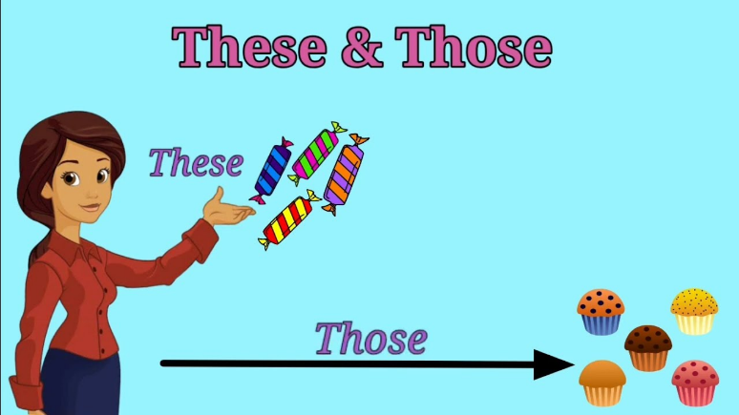
Oefening 3 this, that, these and those door elkaar
- I love _______________ song playing on the radio right now.
- 4. I need to return _______________ library books today.
- 5. Wow, I didn't know _______________ place existed; it's amazing!
- I just finished reading _______________ book, and I highly recommend it.
- 20. Let's go explore _______________ charming little town over the weekend.
- I can't believe I forgot to bring _______________ important documents to the meeting.
- Check out _______________ new gadget I just bought; it's so cool!
- Do you see _______________ building across the street? It has a unique design.
- I found _______________ interesting article in the newspaper about space exploration.
- I really like _______________ car parked in front of our house; it looks so sleek.
- Can you hand me _______________ tools? I need to fix a loose screw.
- 9. I can't believe I ate _______________ entire pizza by myself; it was too delicious to stop.
- Have you met _______________ friendly dog that lives next door?
- _______________ paintings on the wall were created by a local artist.
- I'm thinking of buying _______________ jacket; it would be perfect for winter.
- Let's explore _______________ part of the city; I heard there are great shops here.
- I always get nostalgic when I listen to _______________ old songs from my childhood.
- Pass me _______________ remote control; I want to change the channel.
- I didn't expect _______________ weather today; it was supposed to be sunny.
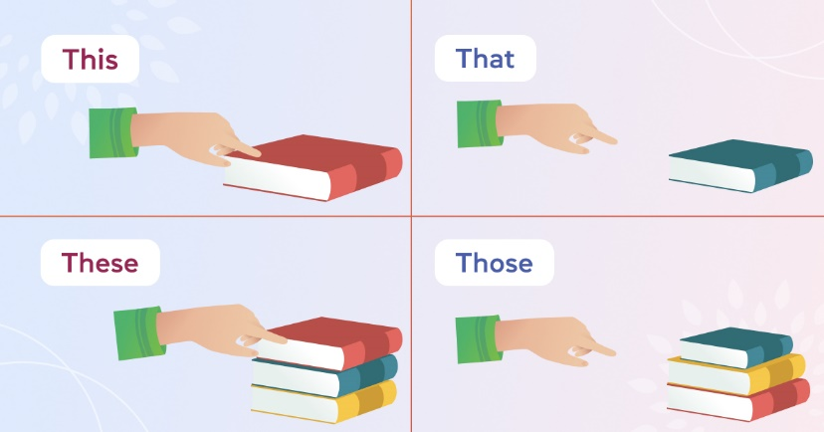
- Do you remember _______________ interesting conversation we had last week?

